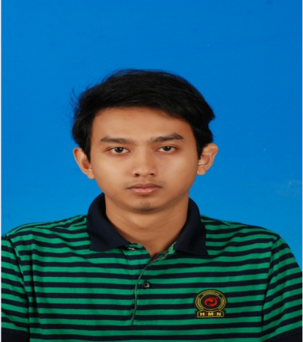

|  |
| --- |
| **PERSONAL PARTICULAR** |

Name : Mohamad Shakir Bin Suidan

Date of Birth : 12/8/1992

NRIC : 920812-03-5113

Gender : Male

Marital Status : Single

Country of Origin : Malaysia

Health : Excellent

Email Address : shakirsuidan@gmail.com

Phone Number : 013-6363619

Permanent Address : Lot 2527, Kampung Wakaf Stan,

: Kubang Kerian,

City : Kota Bharu

Postal Code : 16150

State : Kelantan

|  |
| --- |
| **WORK EXPERIENCE** |

Company : D LA TECHNOLOGY SDN BHD

Location : No.54 & 54A, Jalan Keluli AN7/AN, Pusat Perniagaan Bukit

Raja, Seksyen 7, 40000 Shah Alam, Selangor.

Company Industry : Telecommunication Engineering

Position Title : Project Engineer

Period : 25 April 2016 - Present

Job Description : 1. To assist Head of Technical/Operation.

2. To conduct meeting with Supervisor 2 times a week and

send the report to Head of Technical/Operation.

3. Monitoring planning and implementation of project.

4. Define project tasks and resource requirements.

5. Assemble and coordinate all site supervisor and

subcontractors.

6. Constantly monitor and report on progress of the project to

Head of Technical/Operation.

7. Present reports defining project progress, problems and

solutions.

8. Implement and manage project changes and interventions

to achieve project outputs.

9. Project evaluations and assessment of results.

Depending on the project, responsibilities can cover all aspects of a project from the beginning stages through to completion.

Company : TalentCorp

Location : Putrajaya

Program : Oil & Gas CAD Enhancement Program

Position Title : Trainee

Period : 2 Month (October 2015 – December 2015)

Job Description : Up skilling Program.

- AutoCAD P&ID

- AutoCAD Plant Design 3D

- Inventor

- Navisworks

- Plant Project Administration

Company : Erawan Industry Sdn Bhd

Location : Lot 1052, Kg Kemayang, Tawang 16020, Bachok, Kelantan

Company Industry : Manufacturing Engineering

Position Title : Industrial Training

Period : June 2014 – August 2014

Job Description : Applied engineering knowledge into the problem faced,

learned the process making cylinder gas, used arc welding, oxy cutting and appropriate tools in repairing or modifying facilities, learned the way in maintaining machines and tools

|  |
| --- |
| **EDUCATION BACKGROUND** |

Highest Education Level : Bachelor of Mechanical Engineering

Major : Design and Innovation

Name of Institution : Universiti Teknikal Malaysia Melaka (UTeM)

CGPA/ Achievement : 2.65

Year : 2011-2015

Final Year Project : Design the new mechanical lawn mowers that are

environmentally friendly as well as user-friendly. The

research scope of the design is a study on lawn mowers that

are available in the market today and design new mechanical

lawn mowers by using CAD software. In addition, the

mechanical lawn mowers need to be analyzed their function.

Education Level : Program Matrikulasi Kementerian Pendidikan Malaysia

Major : Science Physic

Name of Institution : Kolej Matrikulasi Perak (KMPk)

CGPA/ Achievement : 2.84

Year : 2010-2011

Education Level : Sijil Pelajaran Malaysia (SPM)

Major : Science

Name of Institution : Sekolah Menengah Kebangsaan Kubang Kerian 2

CGPA/ Achievement : 4A, 3B, 3C

Year : 2009

|  |
| --- |
| **CAREER OBJECTIVE** |

* Having a stable and challenging career that used my personal capability and creativity where I can enhance my skills and improve my knowledge.
* To work in a company with good working environment in order to contribute to the new technology and be a part of it. Also willing to face new challenge in fulfilling the company vision and expanding my carrier.

|  |
| --- |
| **SUPPLEMENTARY AND STRENGTH** |

Willing to Travel : Yes

Willing to be relocated : Yes

Possess own transport : Yes

Driving License : B2 & D

Expected monthly salary : RM 2800 (Negotiable)

Availability : Upon request

Personal Strength : I possess strong teamwork spirit. I am a highly motivated,

confident, fast learner, responsible, hardworking, able to work

under pressure at any condition, able to work for long hours

and handy with technical related equipment.

|  |
| --- |
| **SKILL & LANGUAGE** |

Engineering Software: AutoCAD (P&ID, Plant Design 3D), Inventor, Navisworks,

CATIA, Solidworks

Language Proficiency : Bahasa Melayu, English (Spoken, Listening, Written)

Computer Software: Microsoft office (word, excel, powerpoint)

Other Skills : Good skills in welding, fabrication, and CME

Telecommunication project.

|  |
| --- |
| **REFFERENCE** |

Name : Mohd Nazim Bin Abdul Rahman

Position : Lecturer (Academic Advisor)

Email : nazim@utem.edu.my

Address : Hang Tuah Jaya, 76100 Durian Tunggal, Melaka

Tel : 012-2635758

Name : Mohamad Hazlami Bin Abdul Razak

Position : Senior Executive Chanel Operations

Email : hazlami@prestariang.com.my

Address : Prestariang System Sdn Bhd

70-73, NeoCyber, Lingkaran Cyber Point Barat,

63000, Cyberjaya Selangor

Tel : 013-7106414

Name : Ridhuan Bin Ismail

Position : Project Manager of D LA Technology Sdn Bhd

Email : ridhuan.dlatech@gmail.com

Address : No.54 & 54A, Jalan Keluli AN7/AN, Pusat Perniagaan Bukit

Raja, Seksyen 7, 40000 Shah Alam, Selangor.

Tel : 016-3360114

|  |
| --- |
| **APPENDIXES** |

***1. AUTOCAD CERTIFICATE***

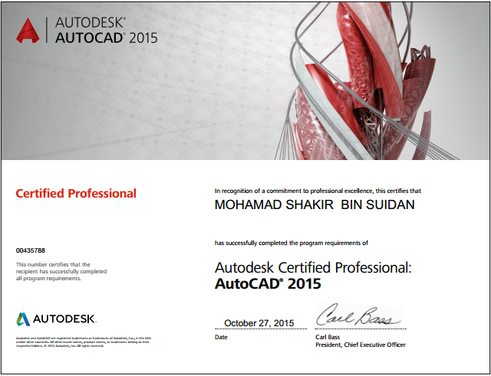

***2. INVENTOR PROFESSIONAL CERTIFICATE***

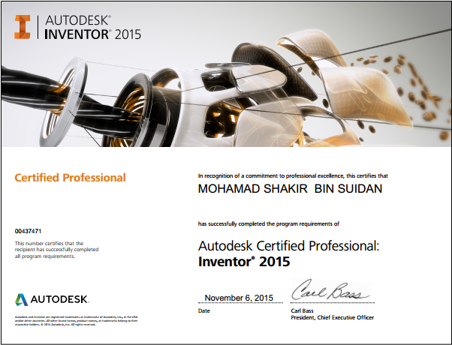

***3. PEC CERTIFICATE***

